**Why Chrome?:**

Welcome to this segment of Getting Started with Google Suite. By the end you should be able to explain the benefits of using Chrome as your browser when working with Google Suite, How to Log your Google Account into the Chrome Browser, along with how to know if you are logged in and how to log out.

Before we jump into the different applications let’s take a moment to talk about internet browsers. Most schools and corporations have the default Internet Explorer installed. While everything we discuss in Getting Started with Google Suite segments 2 through 6 will work in Internet Explorer, or another browser, Chrome offers more conveniences being it was developed by Google.

Some of these conveniences are that once you log your Google account into the Chrome browser any information such as passwords, bookmarks, saved account information can be synced with other Chrome browsers that you log into. You will also not have to constantly log your Google account into the various applications as well. If you are concerned about logging into the Chrome browser on a shared computer, just like with a general Google account, when you are done you can log off, in turn removing all of your personal browsing information from the shared computer.

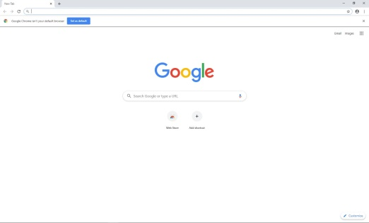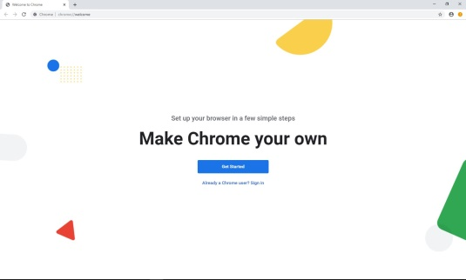

**How to Log In.:**

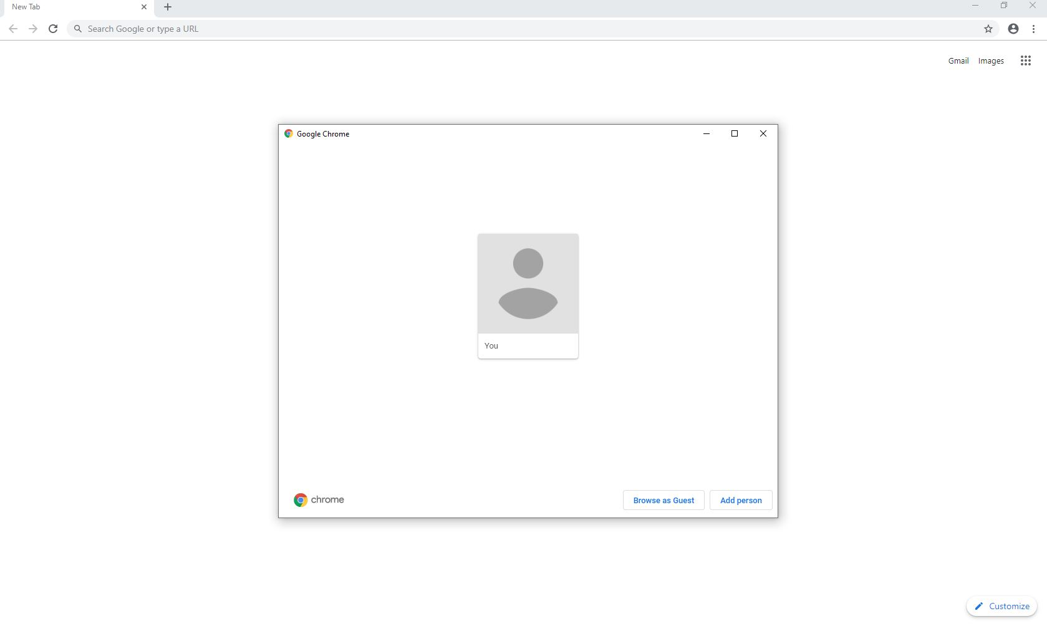

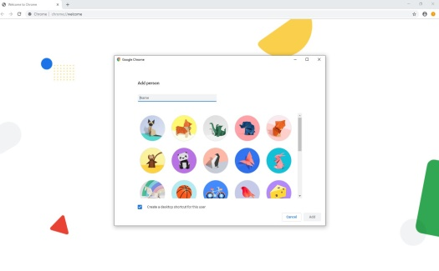There are two ways to go about logging your Google account into the Chrome browser. If when you open Chrome it looks like this (Screen shot on top left) then you will click up on the little grey person, click the “Manage People”, and then click “Add Person”. This will take you to a screen asking for you to enter your name and select an icon. Once you do this and click “Add” you will be taken to a new “Make Chrome you Own” Page (Screen shot on top right). Here you will either click “Get started” if you need to set-up a Google account or you will click “Already a Chrome User? Sign In”.

Most corporations and school systems emails are already set up to interface with Google so go ahead and click “Already a Chrome User? Sign In”. Enter your email, click “Next”, enter your password, click “Next”, and then either click “Yes, I’m In”, which is suggested, or “Cancel” when asked to Turn on Sync. The next decision your will be asked is to either “Skip” or “Set as Default” Chrome as your browser. I generally suggest setting it as your default. That is it, you are now logged in.

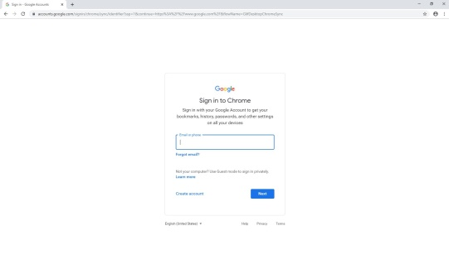As I mentioned there were two ways to go about logging your Google account to your Chrome Browser. What we just walked through is the long way. If you are one of the lucky people and when you open Chrome you are already sitting on the “Make Chrome your Own” Page (Screenshot on top right) then you will just click the “Already a Chrome User? Sign In” and enter your email and password as previously shown.

**How to know you are logged in and How to Log Out.:**

It is easy to tell if you are logged into the Chrome browser. Up in the top right corner you should see your account name if you hover over the circle, if you have a picture set to your account it should also be visible in the circle; otherwise it will show the first letter of your account name. If when you hover mouse over the circle and it says “person 1” or “you” then you are not logged in. Go ahead and go through the log in process.

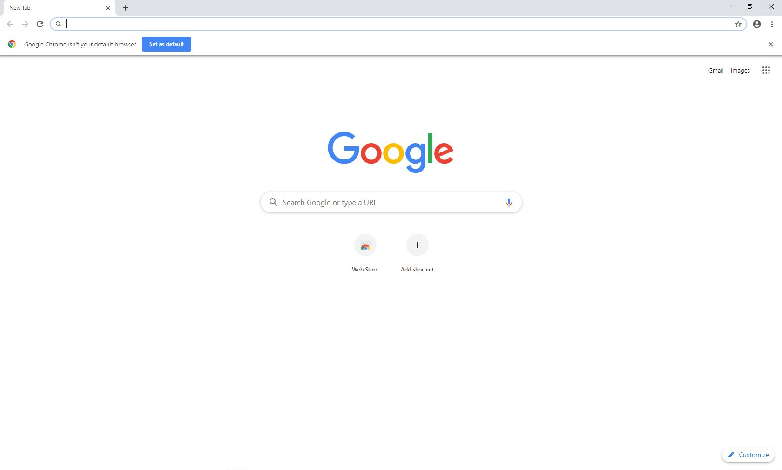

If you would like to log your Google account off of a Chrome browser then you will click on the circle with your account, click manage people on the pop up, click on the triple dots on the top right corner of the user box, then click “Remove this Person”. You will get a warning telling you that it will remove all your browsing history and other personal information that is saved, click “Remove this Person” and you will be taken back to the “Make Chrome you Own” Page.

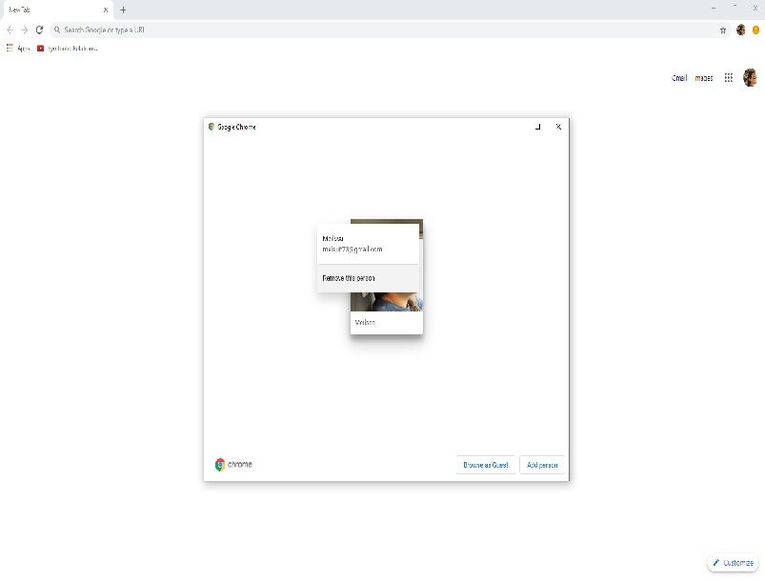

This concludes this segment of Getting Started with Google Suite. By now you should be able to explain the benefits of using Chrome as your browser when working with Google Suite, How to Log your Google Account into the Chrome Browser, along with how to know if you are logged in and how to log out.

Next up is the segment that explores What is Google Drive.